Hotel Room Reservation System – Project Report
Tiago Caetano 1241945, Martim Alves 1240690, Rodrigo Martins 1241122, Ricardo Monteiro 1240842
Abstract: This report describes the modeling process of a hotel room reservation system developed within the scope of the Software Development Fundamentals course. Throughout the document, the main functionalities of the system are explored, accompanied by diagrams that illustrate the interaction between the user and the system. The structure also includes a domain model that represents the essential elements of the application, as well as a glossary clarifying the technical terms used. The purpose of the report is to clearly and systematically document all the work carried out during the system's design.
1 Introduction
This report was created within the scope of the Software Development Fundamentals course and aims to document the design and modeling process of a room reservation system for a specific hotel. The purpose of this system is to allow users to make reservations in a simple and efficient way, as well as leave comments and reviews about their stays.
Throughout the development of the project, fundamental concepts of software analysis and modeling were applied, namely the identification of functionalities, the creation of use cases, sequence diagrams, and the domain model. All the work was focused on clearly representing the internal workings of the system and the interaction of users with it.
2 Domain Model
The domain model graphically represents the main elements of the system as well as the relationships between them.
The entities present in the model reflect the core concepts of the application, such as the hotel, customer, reservation, room, and comments. This diagram serves as a foundation for understanding the internal structure of the system and helps guide its future implementation.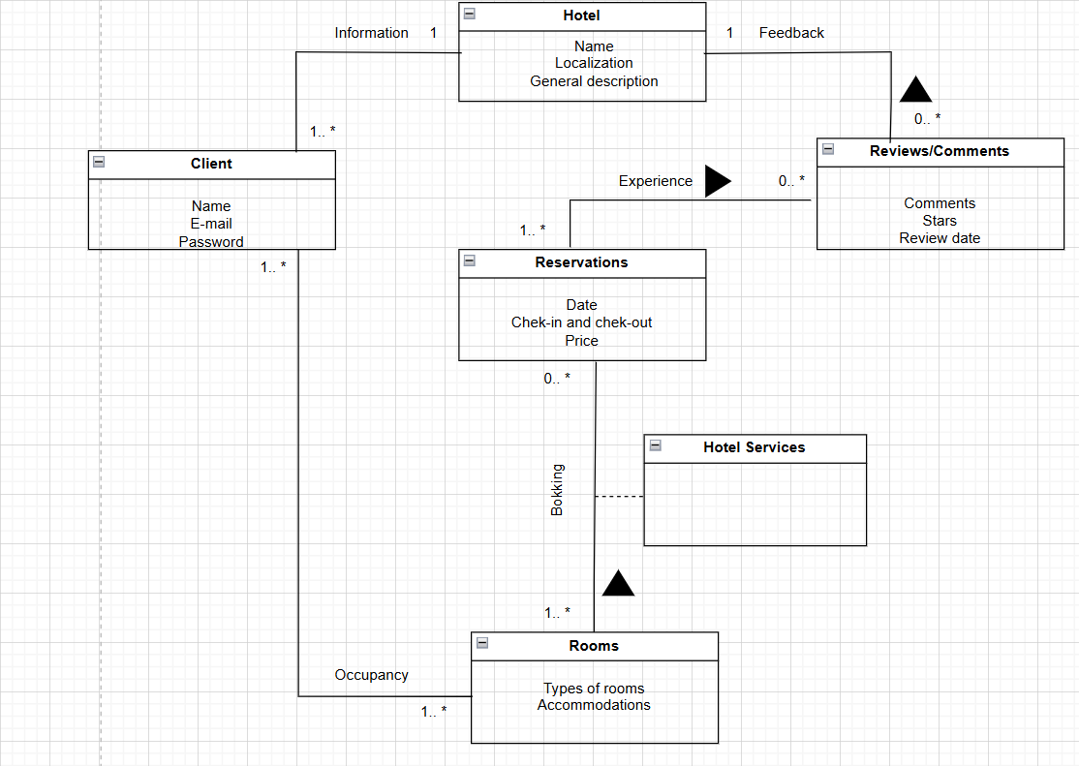

2.1 Glossary
- Client – A person who uses the system to search for hotels, make reservations, and leave comments/reviews. Each client has an associated name, email, and password.
- Hotel – An establishment that offers accommodations and services to clients. It includes data such as name, location, and a general description. Hotels can receive reviews from clients.
- Rooms – Accommodation units within the hotel. They include information such as room type and amenities.
- Reservations – A record of a client’s stay in a hotel room. It contains details such as reservation date, check-in and check-out dates, and the price.
- Hotel Services – Services provided by hotels, such as breakfast, Wi-Fi, spa, among others. These are associated with the reservations made by clients.
- Reviews/Comments – Opinions and ratings left by clients after their stay. They include comments, star ratings, and the date of the review.
3 Requirements
3.1 Functionalities
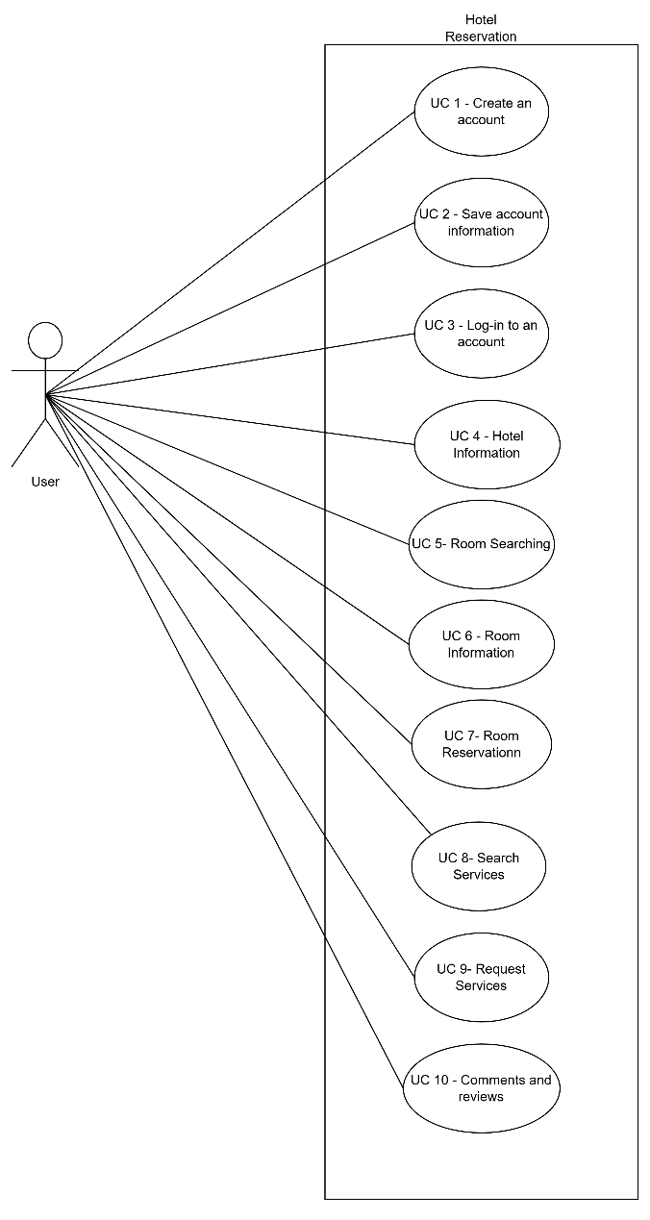

Specification: UC 1 – Create an account

Description | Add one user account to the system.
Pre-condition | There are no pre-conditions associated with this use case.
Post-condition | The number of User accounts has to go up by one.
Basic path | - The User selects the option to create an account.  - The System asks for the user’s data.  - The User enters their data.  - The System validates the data.  - The System stores the data entered.  - The System confirms account creation.
Alternative path | Invalid credentials entered:  - The system asks for the user’s data again.

SSD: UC 1 – Create an account
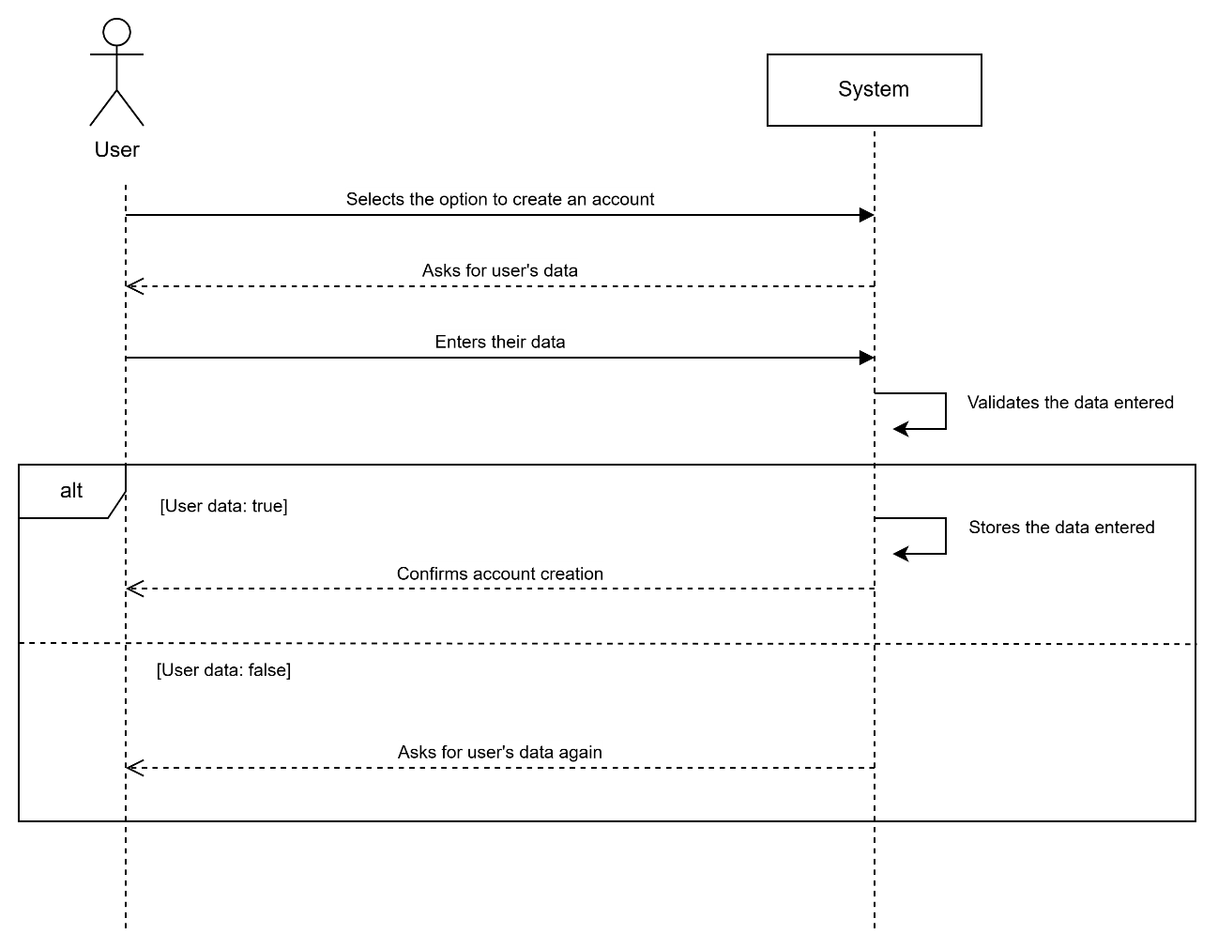
Specification: UC 2 – Save account information

Description | Account created gets saved in the system alongside the credentials.
Pre-condition | The User needs to create a valid account.
Post-condition | Account can be accessed anytime, after being created.
Basic path | - The User completes the account creation process.  - The System confirms the successful creation of the account.  - The System saves all information about the account created.
Alternative path | The system does not confirm account creation:  - The system gives the option to either log in or create an account.

SSD: UC 2 – Save account information
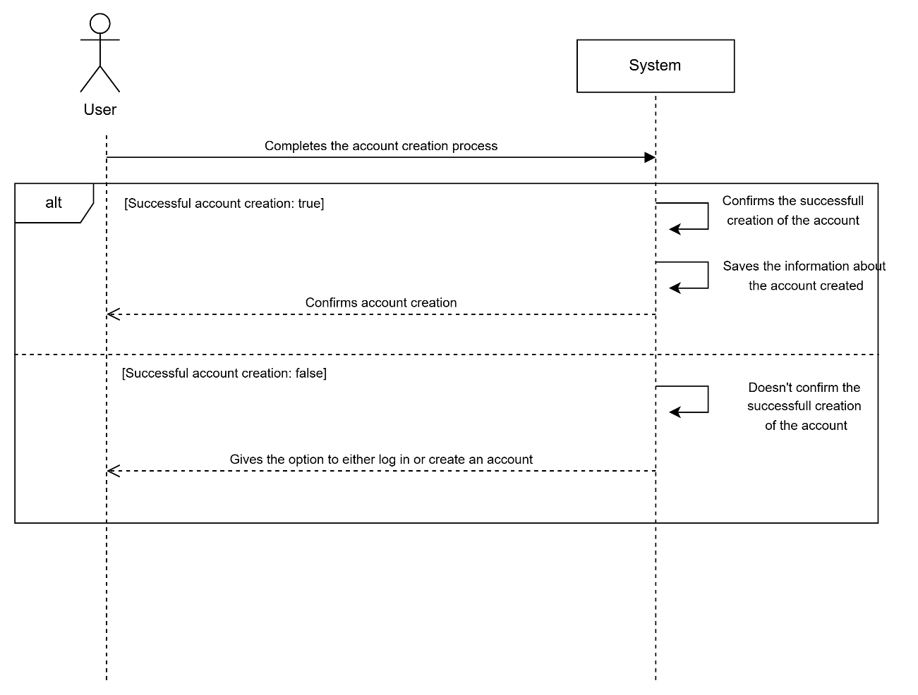
Specification: UC 3 – Log in to an account

Description | User acesses his account by entering it’s details.
Pre-condition | An account with valid credentials has to be created.
Post-condition | User logs into their account.
Basic path | - The User selects the option to log in to an account.  - The System asks for the account’s credentials.  - The User enters the account details, of the account they want to log in.  - The System verifies the credentials entered.  - The System logs the user into the account.
Alternative path | Wrong credentials entered:  - The System notifies the User and asks them to re-enter their credentials.

SSD: UC 3 – Log in to an account
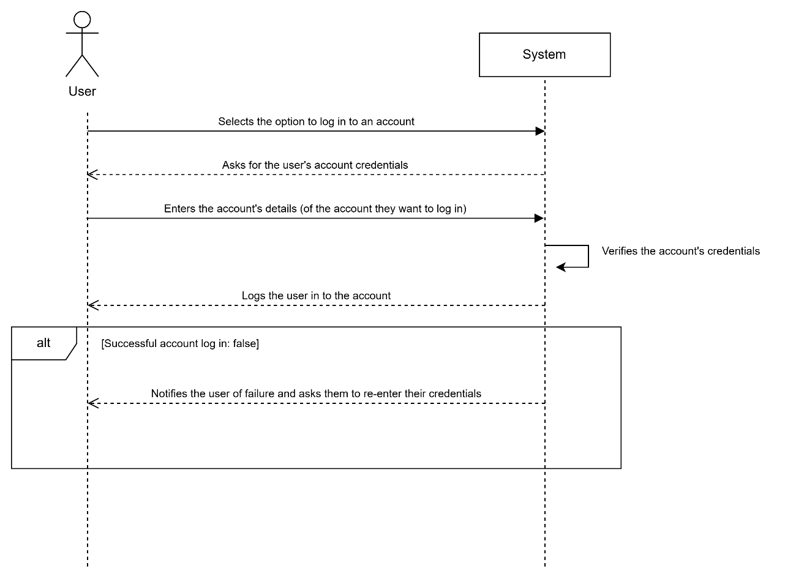
Specification: UC 4 – Hotel Information

Description | The Hotel information is given to the User by the System.
Pre-condition | The User needs to have clicked in information for the Hotel.
Post-condition | The information and details about the Hotel is given to the User.
Basic Path | - The User requests information about the hotel.  - The System shows the list of available information.  - The User can choose which detail he wants to see.  - The System checks for the specified detail informaton.  - The specified details will appear.
Allternative Path | There is no detail information.  - The System returns failure.

SSD: UC 4 – Hotel Information
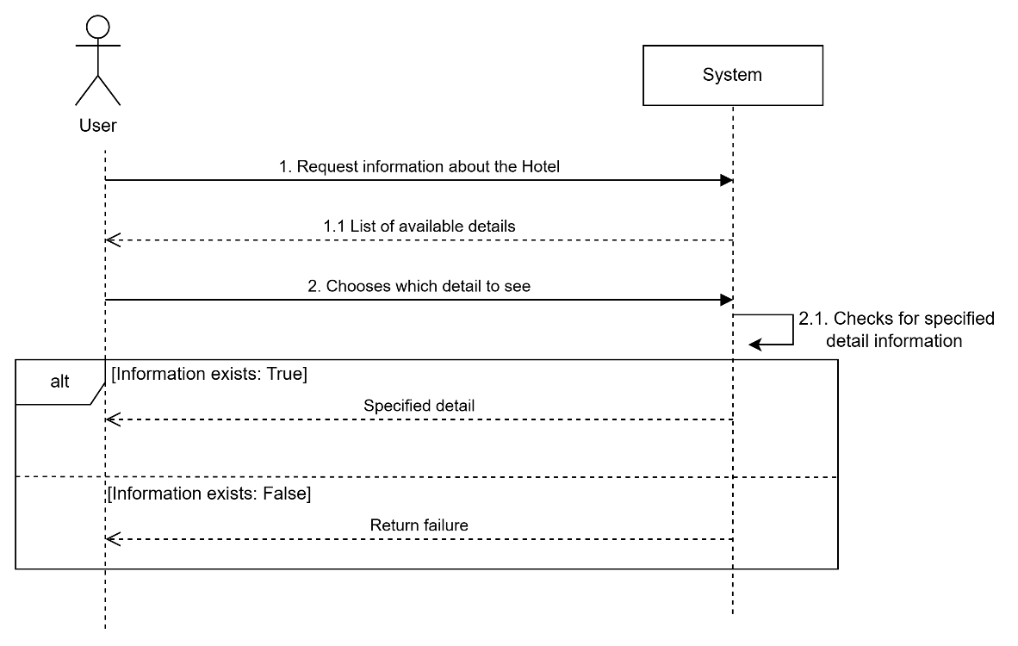
Specification: UC 5 - Room Searching
Description | Search for an available room in the Hotel room System.
Pre-condition | The User needs to have clicked for room information.
Post-condition | The Hotel Room System displays a list of available rooms or informs the User that no rooms are available, preventing further searches.
Basic path | - The User enters search criteria(type of room).  - The System processes the search request.  - The System retrieves matching available rooms.  - The System displays the list of available rooms.
Alternative path | No rooms available:  - The System returns a message: "No rooms available at this time."  - The search process is terminated, preventing further attempts until criteria are changed.

SSD: UC 5 - Room Searching
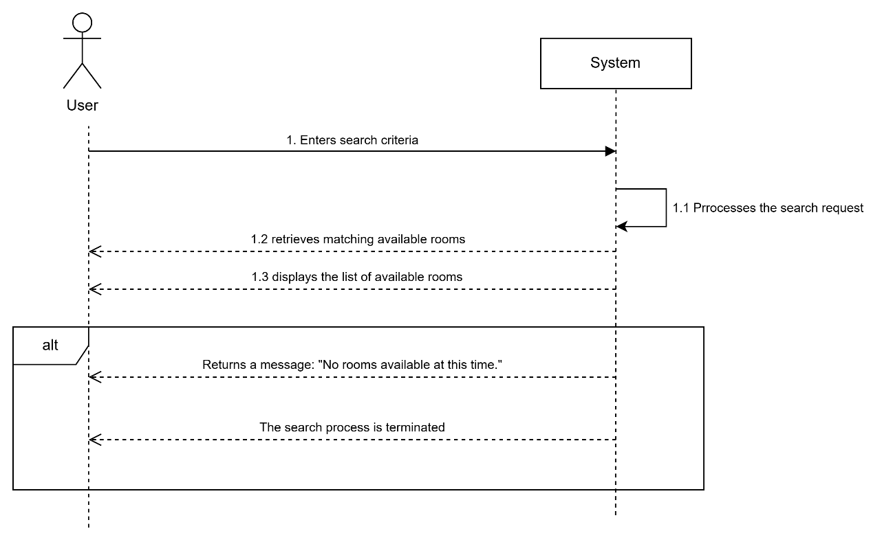
Specification: UC 6 – Room Information

Description | The room information is given to the user by the System.
Pre-Condition | The User needs to have selected a specific room.
Post-Condition | Information about a specific room is shown to the User.
Basic Path | - The User requests information about the rooms.  - The System returns a list of available rooms.  - The User chooses what room to see.  - The System checks for available information about the room.  - The System returns the room information and details.
Alternative Path | The room information doesn’t exist:  - The system returns failure.

SSD: UC 6 – Room Information
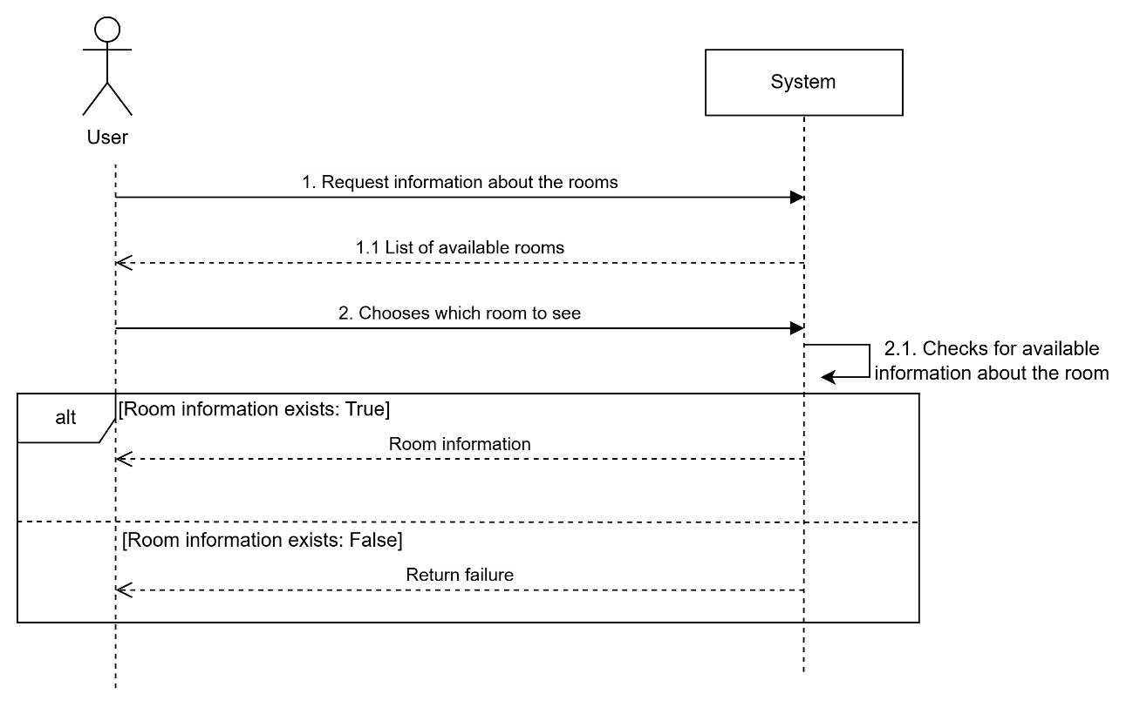
Specification: UC 7 - Room Reservation

Description | Reserve a selected room in the System.
Pre-condition | The User has selected an available room.
Post-condition | The System confirms the reservation and updates room availability.
Basic path | - The User selects an available room.  - The User enters reservation details.  - The System validates the reservation details.  - The System stores the reservation.  - The System confirms the reservation.
Alternative Path | Invalid reservation details:  - The System returns an error and prompts the User to correct the details.  Room becomes unavailable during the process:  - The System notifies the User and prevents the reservation from proceeding.

SSD: UC 7 - Room Reservation
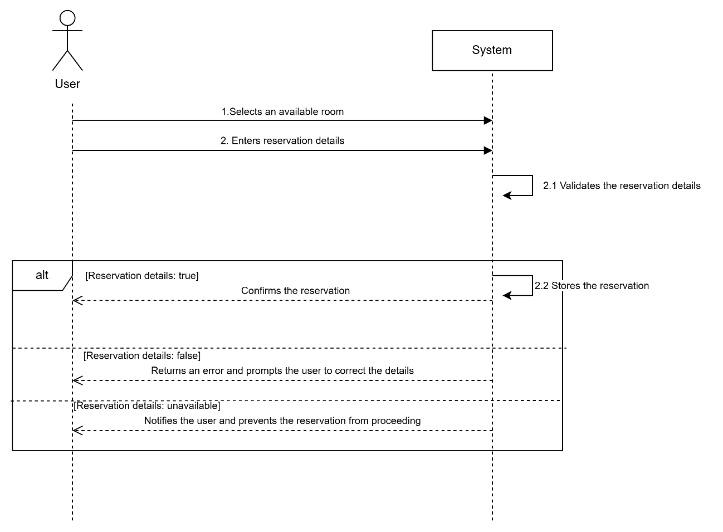
Specification: UC 8 – Search Services

Description | Allows the User to view Hotel services
Pre-Condition | The User must be logged in to their account.
Post-Condition | The System displays the list of available services
Basic Path | - The User navigates to the Hotel services section.  - The System retrieves the list of available Hotel services.  - The System displays the services along with descriptions and pricing.
Alternative Path | No services available:  - The System returns a message: “No services are currently available.”

SSD: UC 8 – Search Services
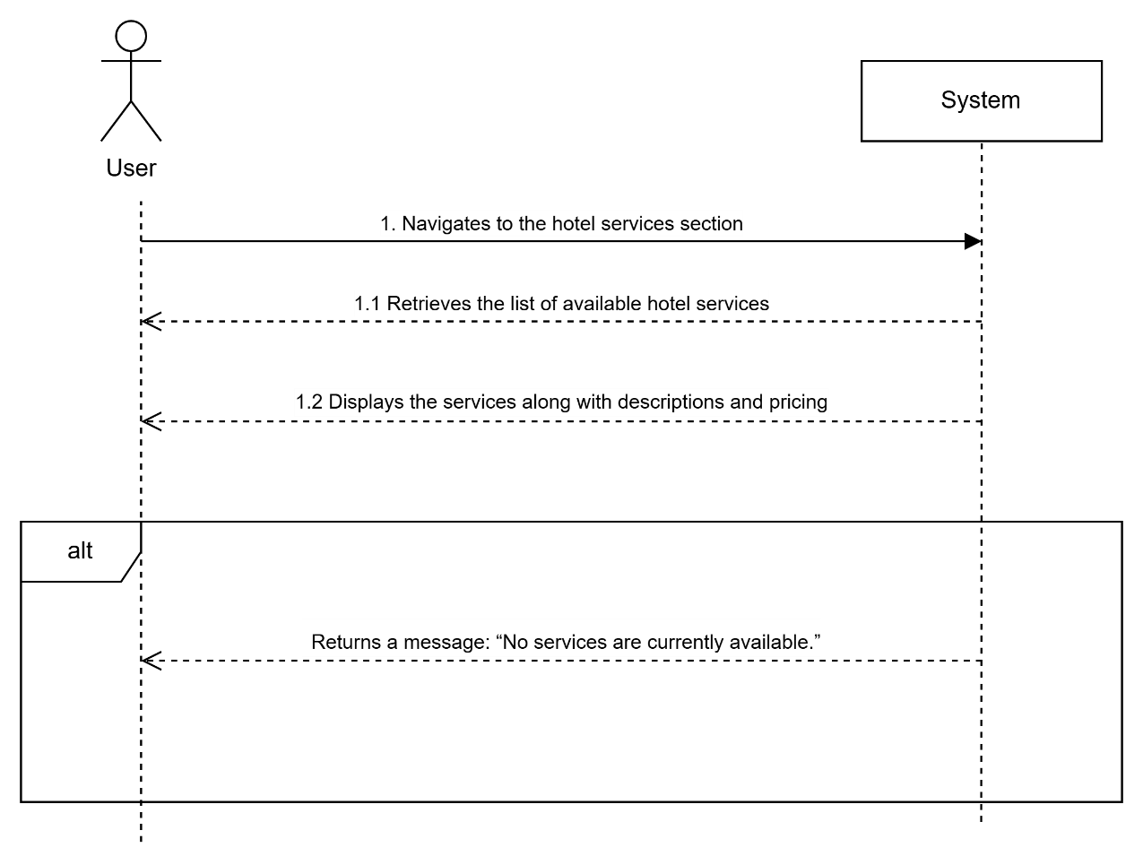
Specification: UC 9 - Request Services
Description | Allow the User to request a Hotel service.
Pre-condition | The User must be logged into the System and have an active room reservation.
Post-condition | The System processes the request and updates the request status.
Basic path | - The User requests information about the services.  - The System returns a list with the available services.  - The User chooses which service to see.  - The Service’s details and prices are returned to the User.  - The User confirms the service request.  - The System processes the request.  - The System confirms the request and returns a confirmation to the User.  - The System Stores the request data, making it available to the User to see later.
Alternative path | Service unavailable:  - The System notifies the user that the service is temporarily unavailable and returns failure.

SSD: UC 9 - Request Services
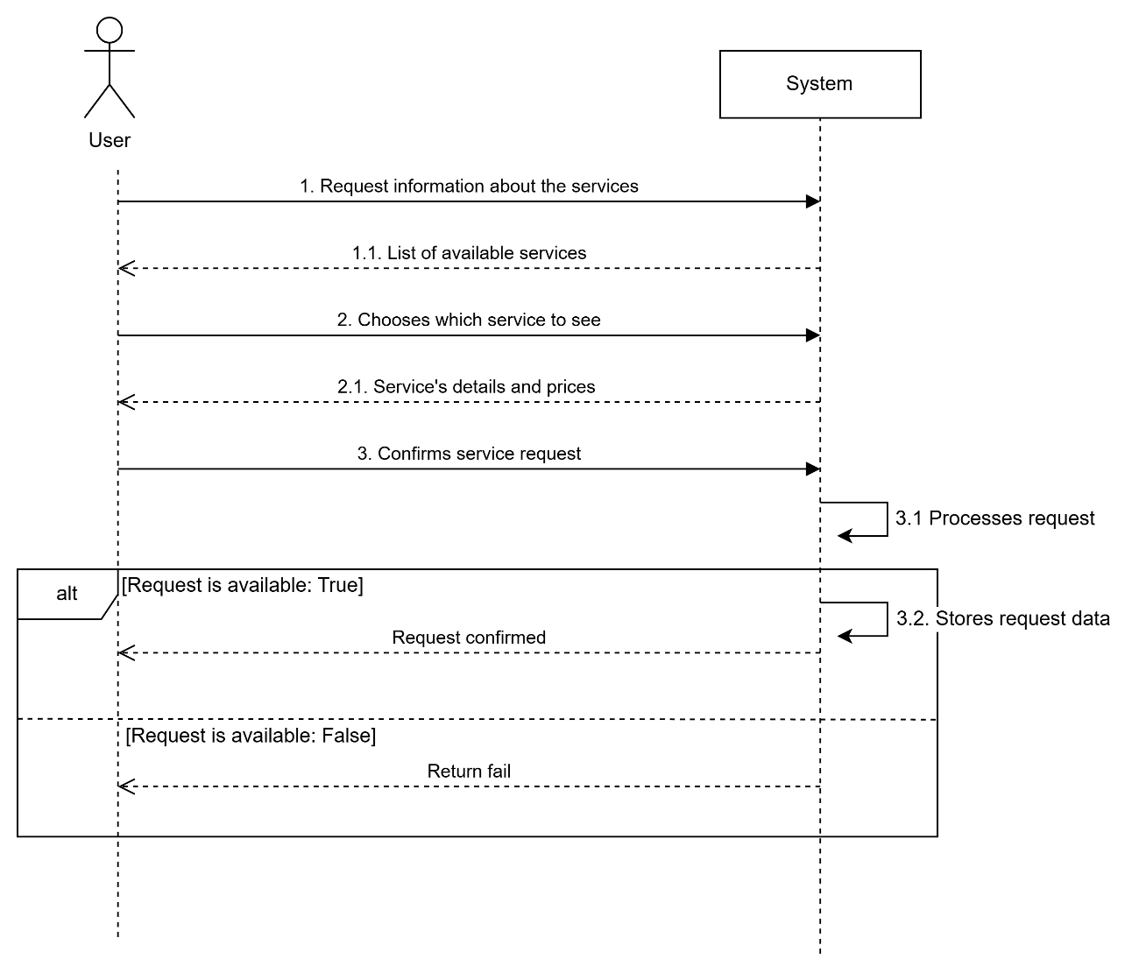
Specification: UC 10 – Comments and reviews

Description | Allows the User to leave a review and comment
Pre-Condition | The User must be logged in to their account.
Post-Condition | The System saves and posts the comment on the Hotel page
Basic Path | - The User navigates to the Hotel review section.  - The User selects to write a review and comment.  - The System asks for the number of stars of the review.  - The User enters the number of starts.  - The System validates the number.  - The System asks for the user to write the comment.  - The User writes the comment.  - The System validates the comment.  - The User chooses to post the comment.  - The System saves both the number of starts and the comment.  - The System posts both the number of stars and the comment on the Hotel page.
Alternative Path | The User only posts the number of stars:  - The System only posts the number of stars without a comment.  The User chooses not to post the comments:  - The System doesn’t save what the user wrote.  - The System goes back to the review/comments section.

SSD: UC 10 – Comments and reviews
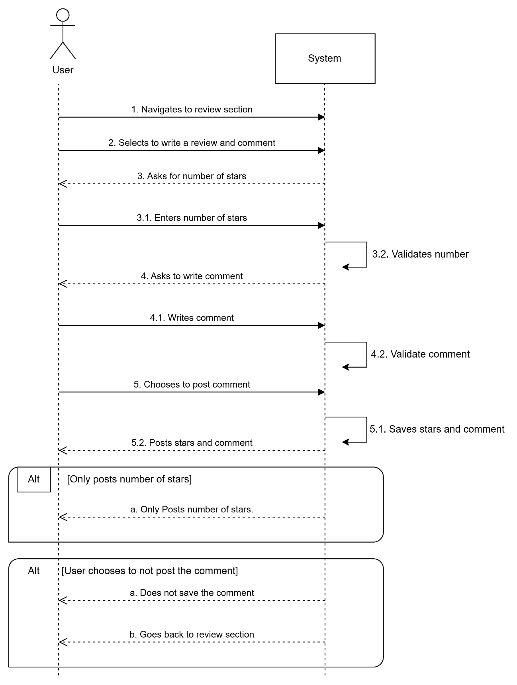

  - Non-Functionalities

- Usability: Console-based user interface
- Reliability: No
- Performance: No
- Supportability: Huge amount of tests (unit tests)
- Design constraints: Data persistent in binary files
- Implementation constraints: C++ Language
- Interface constraints: No

